**1.** Converse, Inverse, and Contrapositive

In mathematics, there are many rules, properties, and theorems that are stated using ***if…then***.

These are conditional statements, **p 🡒 q**, if *p* then *q*

If ***p*** and ***q*** are interchanged, negated, or both then a new conditional statement is formed.

1. Look at the following statement:

_________________________: If I go, then you stay.

***p*** is _______________________________________

***q*** is _______________________________________

2. Let’s interchange ***p*** and ***q***, in other words, switch their position in the statement:

_________________________:

3. Look back at #1, the original conditional statement. Now let’s write the ***p*** and ***q*** as a negation:

_________________________:

4. Look back at #2, the converse statement. Now let’s write the ***p*** and ***q*** as a negation:

_________________________:

Conditional……opposite……Inverse (the negative)

Converse……...opposite……Contrapositive (the negative)

**EXAMPLE:** Write the three related statements given the conditional statement:

**Conditional:** If there is smoke then there is fire.

**Converse:** _________________________________________________________________

**Inverse:** ___________________________________________________________________

**Contrapositive:** _____________________________________________________________

Here is a chart that shows all four conditional and related statements in symbol form.

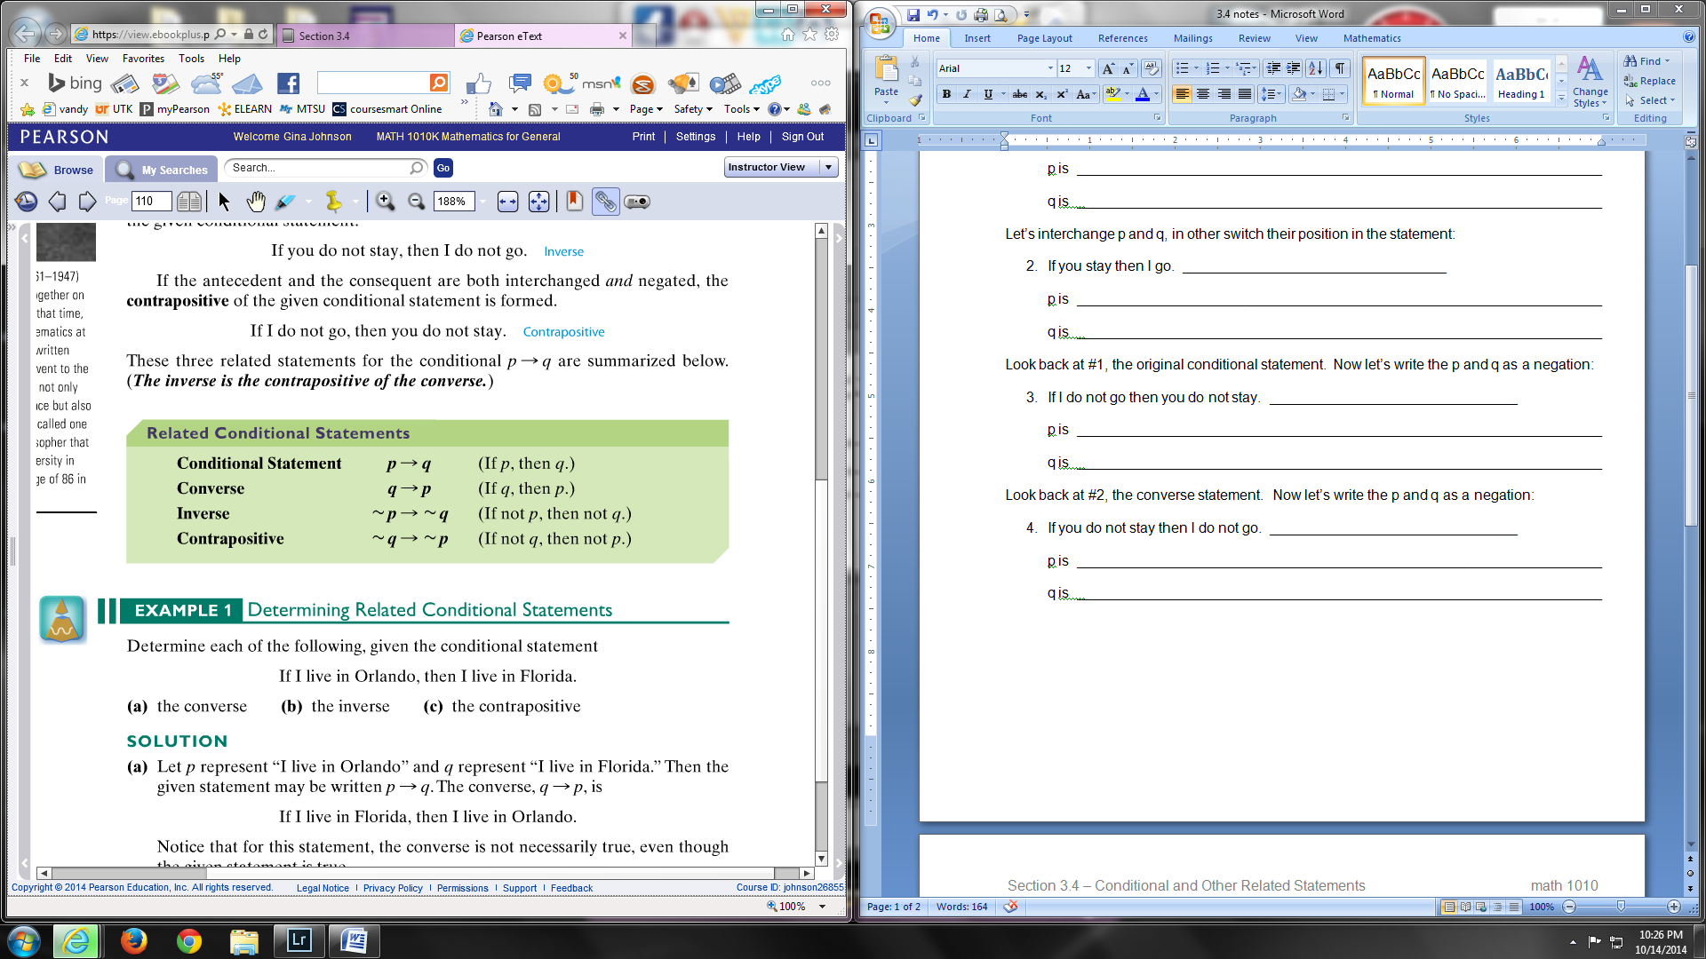

**EXAMPLE:** Write in symbol form, the three related statements given the conditional statement. Make sure to simplify two negatives, just like in regular math.

**Conditional:** ~ p 🡒 q

**Converse:**

**Inverse:**

**Contrapositive:**

**EXAMPLE:** Translate the conditional statement into symbols.

The translation might be the converse, inverse, or contrapositive.

A triangle is equilateral only if it has three sides of equal length.

***p*** = A triangle is equilateral

***q*** = a triangle has three sides of equal length

1. A triangle is equilateral if it has three sides of equal length. ___________

2. If a triangle is not equilateral then it does not have three sides of equal length. __________

**2.** Biconditional statements

A compound statement using the words **“if and only if”** (abbreviated as *iff* ) is called a biconditional statement, ***p* ⭤ *q***, *p if and only if q* *p iff q*

Biconditional means there are two conditions: ***p 🡒 q*** and ***q 🡒 p***

Therefore in symbol form:

Construct the truth table for “biconditional”

|  |  |  |  |  |
| --- | --- | --- | --- | --- |
| p q | p 🡒 q | q 🡒 p | (p 🡒 q) ∧ (q 🡒 p) | p 🡘 q |
| T T  T F  F T  F F |  |  |  |  |

Notice that a biconditional statement is true when both ***p*** and ***q*** statements are the _________.

**EXAMPLE:** Determine if each biconditional statement is TRUE or FALSE.

1. 6 + 8 = 14 if and only if 11 + 5 = 16 ________________________________
2. 5 + 2 = 10 if and only if 17 + 19 = 36 ________________________________
3. 6 = 5 if and only if 12 ≠ 12 ________________________________
4. Apple makes Ipods if and only if ________________________________

Burger King sells Big Macs

**3.** Consistent and Contrary

If two statements are **both true** about the same object, the statements are _______________

EXAMPLE: “the apple is red” and “it weighs 12 ounces”

If two statements **cannot** be true about the same object, the statements are ______________

EXAMPLE: “the apple is red” and “the apple is green”

**EXAMPLE:** decide if each pair of statements are consistent or contrary

__________________ Elvis is dead. Elvis is alive!

__________________ George Bush was a republican. George Bush was a Democrat.

__________________ That animal has four legs. That animal is a tiger.

__________________ Pi is an irrational number. Pi is a whole number.

__________________ This number is a whole number. This number is an integer.